SIMATS ENGINEERING
(SAVEETHA SCHOOL OF ENGINEERING)
Department of Computer Science and Engineering
CO3 ASSESSMENT TOOL 1
Git & Docker Technical Assignment Report
On the Problem Statement:
SkillSphere — AI-Driven Career Readiness and Personalized Learning Recommendation Platform
Course Code: CSA10 / CSA1063
Course Title: Software Engineering
CO Assessed: CO3 — Build full-stack applications with an emphasis on containerization, version control, and collaborative development
Weightage: 20% | Total Marks: 25 | Duration: 60 minutes
Student Name: __B Lakshmi narasimhudu____________________________
Register No.: _192525460_____________________________
Date: __08-08-2026____________________________
SIMATS ENGINEERING
Saveetha Institute of Medical and Technical Sciences
Chennai – 602105
August 2026

Code of Conduct
I ___B Lakshmi Narasimhudu_(192525460)(Name / Reg No) certify that this submission is my original work and that I have adhered to the guidelines specified for this assessment. I understand that any violation of academic integrity rules will result in disciplinary action.
Signature of the Student: ___B Lakshmi narasimhudu___________________________

ABSTRACT
This report documents the application of version control and containerization practices to SkillSphere, an AI-Driven Career Readiness and Personalized Learning Recommendation Platform designed to bridge the gap between academic learning and industry skill requirements. As part of CO3 Assessment Tool 1 (Git & Docker Technical Assignment), the report analyses the SkillSphere problem statement, designs a modular project repository structure, and establishes a Git workflow built around a Main-Development-Feature-Release-Hotfix branching model suited to a multi-service application comprising a React front end, a Node.js REST API, a Python-based Machine Learning recommendation service, and supporting data stores.
The report further details the containerization strategy adopted for SkillSphere, including the design of individual Dockerfiles for each service, a Docker Compose configuration that orchestrates the frontend, backend, ML microservice, PostgreSQL database, and Redis cache within an isolated network, and the deployment and testing procedure used to verify that the containerized application runs correctly end-to-end. Command sequences, tables, and architecture diagrams are included throughout to demonstrate each stage of the workflow.
Finally, the report discusses how Git and Docker jointly improve collaboration, reproducibility, portability, and scalability for the SkillSphere platform, and reflects on the practical challenges encountered — such as merge conflicts, environment parity, and multi-container networking — together with recommended improvements for future iterations of the development pipeline.
Keywords: Git, Docker, Version Control, Containerization, Branching Strategy, Docker Compose, CI/CD, SkillSphere, Software Engineering.

TABLE OF CONTENTS
1. Problem Analysis 1
2. Project Structure Design 2
3. Git Repository Initialization 3
4. Git Branching Strategy 4
5. Version Control Workflow 5
6. Commit History Analysis 6
7. Docker Environment Design 7
8. Dockerfile Development 8

CHAPTER 1

PROBLEM ANALYSIS

1.1 Problem Statement
Educational institutions and students face a widening gap between academic curricula and the practical, fast-changing skill requirements of the technology industry. Students frequently graduate without a clear understanding of which competencies employers value, and institutions lack intelligent tools to monitor employability beyond raw academic grades. SkillSphere is proposed as an AI-Driven Career Readiness and Personalized Learning Recommendation Platform that analyses a learner's academic records, technical skills, certifications, project work, coding profiles, aptitude, and career interests, and combines this with real-time labour-market data to recommend personalised learning paths, certifications, projects, and career directions.

1.2 Project Objectives
- Skill Gap Identification: Automatically detect the gap between a student's current competencies and the requirements of their target career role.
- Personalized Recommendations: Use Machine Learning to recommend courses, certifications, projects, and internships tailored to each learner.
- Career Path Prediction: Classify learners into suitable career domains (e.g., AI Engineer, Data Scientist, Full-Stack Developer) using predictive models.
- Progress Monitoring: Provide interactive dashboards for students and faculty to track competency growth over time.
- Reproducible, Portable Delivery: Package the platform so that it can be version-controlled collaboratively and deployed consistently across development, testing, and production environments using Docker.

1.3 Functional Requirements
ID | Functional Requirement | Description
FR-1 | Learner Profile Management | Capture academic records, skills, certifications, and career interests.
FR-2 | Skill Gap Analysis Engine | Compare learner competencies against industry-defined skill benchmarks.
FR-3 | Recommendation Engine | Generate personalised course, certification, and project recommendations using ML models.
FR-4 | Career Prediction Module | Predict the most suitable career domain(s) for a learner.
FR-5 | Dashboard & Analytics | Visualise progress, competency scores, and employability indicators.
FR-6 | Authentication & Roles | Support student, faculty, and administrator roles with secure login.

CHAPTER 2

PROJECT STRUCTURE DESIGN

2.1 Repository Folder Structure
SkillSphere is organised as a multi-service (polyrepo-in-a-monorepo style) project so that the frontend, backend API, ML recommendation service, and infrastructure configuration can be developed, versioned, and containerized independently while still living in a single Git repository for ease of coordination.
skillsphere/
├── frontend/ # React.js client application
│ ├── src/
│ ├── public/
│ ├── package.json
│ └── Dockerfile
├── backend/ # Node.js / Express REST API
│ ├── src/
│ │ ├── controllers/
│ │ ├── routes/
│ │ ├── models/
│ │ └── middleware/
│ ├── package.json
│ └── Dockerfile
├── ml-service/ # Python / Flask recommendation engine
│ ├── app/
│ │ ├── models/ # trained ML model artifacts
│ │ ├── recommender.py
│ │ └── api.py
│ ├── requirements.txt
│ └── Dockerfile
├── database/
│ └── init.sql # schema & seed scripts
├── docs/
│ ├── architecture-diagram.png
│ └── er-diagram.png
├── .github/workflows/ # CI pipeline definitions
│ └── ci.yml
├── docker-compose.yml
├── .env.example
├── .gitignore
├── .gitattributes
└── README.md
Figure 2.1 — SkillSphere repository folder structure

2.2 Purpose of Major Folders and Files
Folder / File | Purpose
frontend/ | Contains the React single-page application that students and faculty use to view dashboards and recommendations.
backend/ | Hosts the Express REST API that exposes endpoints for authentication, profile management, and orchestration of the recommendation workflow.
ml-service/ | Isolates the Machine Learning recommendation and career-prediction logic in its own Python service so it can be scaled and updated independently of the API.
database/init.sql | Defines the initial relational schema and seed data used when the PostgreSQL container starts for the first time.
docs/ | Stores architecture diagrams, ER diagrams, and design documentation referenced in this report.
.github/workflows/ci.yml | Defines the Continuous Integration pipeline that lints, tests, and builds Docker images on every push.
docker-compose.yml | Orchestrates all containers (frontend, backend, ml-service, database, cache) as a single multi-container application.
.env.example | Documents required environment variables without exposing actual secrets in version control.
.gitignore | Excludes build artifacts, node_modules, Python virtual environments, and local .env files from version control.
README.md | Provides setup instructions, architecture overview, and contribution guidelines for new developers.

2.3 Design Justification
Separating the frontend, backend, and ML service into distinct top-level folders mirrors the eventual container boundaries defined in Chapter 9 (Docker Compose Design), so that each folder maps one-to-one onto a Docker build context. This keeps Dockerfiles simple (each only needs to COPY its own folder), allows each service to have independent dependency files (package.json vs. requirements.txt), and lets different teams work on different services without touching unrelated code — which in turn keeps Git history clean and reduces merge conflicts.

CHAPTER 3

GIT REPOSITORY INITIALIZATION

3.1 Creating the Repository
The SkillSphere repository was initialised locally and then linked to a remote hosting service (GitHub) to enable collaboration. The steps performed are shown below.
$ mkdir skillsphere && cd skillsphere
$ git init
Initialized empty Git repository in /skillsphere/.git/

$ git branch -M main
$ echo "# SkillSphere" >> README.md
$ git add README.md .gitignore
$ git commit -m "chore: initial commit with README and gitignore"

$ git remote add origin https://github.com/<org>/skillsphere.git
$ git push -u origin main
Figure 3.1 — Repository initialization command sequence

3.2 Purpose of Essential Git Files
File | Purpose
.git/ | Hidden directory created by 'git init' that stores the entire object database, refs, and configuration for the repository — this is what makes the folder a Git repository.
.gitignore | Lists files and folders (node_modules/, __pycache__/, .env, dist/, *.log) that Git should never track, keeping the history free of build artefacts and secrets.
.gitattributes | Normalises line endings (LF) across Windows/Linux/Mac contributors and marks binary files so they are not diffed as text.
README.md | Onboards new contributors with setup, run, and contribution instructions.
LICENSE | States the terms under which the SkillSphere source code may be reused.

3.3 Explanation of Initialization Steps
- git init creates the local repository and the hidden .git metadata directory that tracks every future change.
- git branch -M main renames the default branch to main, aligning with the branching strategy in Chapter 4.

CHAPTER 4

GIT BRANCHING STRATEGY

4.1 Selected Branching Model
SkillSphere adopts a Git Flow-inspired branching model with five branch types: Main, Development, Feature, Release, and Hotfix. This model was selected because SkillSphere is a multi-service academic/production-track application where stability of the main branch (used for demos and grading) must be preserved while multiple contributors work in parallel on the frontend dashboard, the recommendation engine, and the Docker/CI infrastructure.
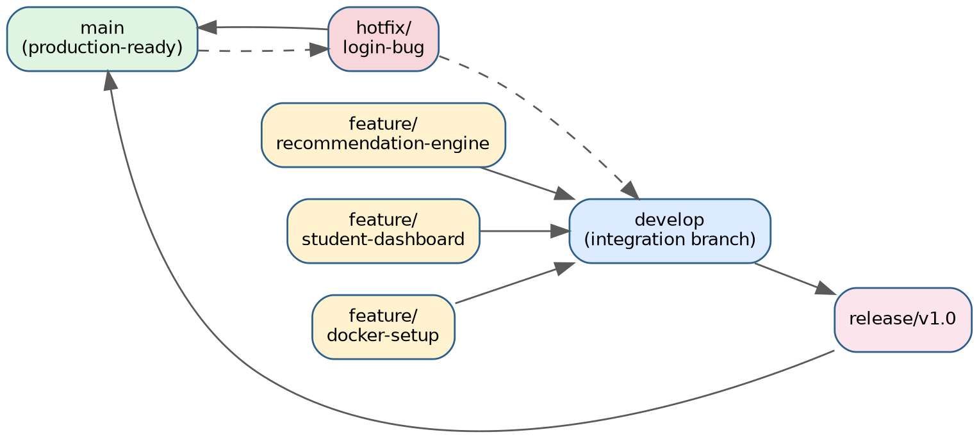
Figure 4.1 — SkillSphere Git branching strategy

4.2 Branch Roles
Branch | Role
main | Always deployable, production-ready code. Only updated via merges from release or hotfix branches.
develop | Integration branch where completed features are merged and tested together before a release is cut.
feature/* | Short-lived branches for individual features, e.g. feature/recommendation-engine, feature/student-dashboard, feature/docker-setup. Branched from develop, merged back into develop.
release/* | Prepares a stable version for release (final testing, version bump, documentation). Branched from develop, merged into both main and develop.
hotfix/* | Urgent fixes applied directly against main for critical production bugs, then merged back into both main and develop.

CHAPTER 5

VERSION CONTROL WORKFLOW

5.1 Feature Development Workflow
$ git checkout develop
$ git pull origin develop
$ git checkout -b feature/recommendation-engine

# ... implement the ML recommendation endpoint ...
$ git add ml-service/app/recommender.py
$ git commit -m "feat(ml-service): add content-based course recommender"

$ git push -u origin feature/recommendation-engine
# Open a Pull Request: feature/recommendation-engine -> develop
Figure 5.1 — Feature branch creation and commit

5.2 Merging
Once a feature branch passes code review and CI checks, it is merged into develop. A non-fast-forward merge is used to preserve the feature's commit history and clearly mark integration points.
$ git checkout develop
$ git pull origin develop
$ git merge --no-ff feature/recommendation-engine
$ git push origin develop

5.3 Conflict Resolution
A conflict occurred when two contributors both modified backend/src/routes/api.js — one adding a /recommendations route and the other adding a /career-prediction route on the same line range. The conflict was resolved as follows:
$ git merge feature/career-prediction
Auto-merging backend/src/routes/api.js
CONFLICT (content): Merge conflict in backend/src/routes/api.js
Automatic merge failed; fix conflicts and then commit the result.

# Manually edited api.js to retain BOTH route definitions
$ git add backend/src/routes/api.js
$ git commit -m "merge: resolve route conflict, keep recommendation and prediction routes"
$ git push origin develop
Figure 5.2 — Conflict resolution during merge

5.4 Repository Synchronization
All contributors regularly synchronise their local branches with the remote using git fetch and git pull --rebase to minimise divergence, and git push to publish completed work. This keeps develop consistently up to date across the team and reduces the frequency and complexity of merge conflicts.

5.5 Purpose of Each Operation
- git checkout -b: creates and switches to an isolated branch so in-progress work never destabilises develop or main.
- git add / git commit: stage and permanently record a logical, reviewable unit of change with a descriptive message.
- git push: publishes local commits to the shared remote so teammates and CI can access them.
- git merge --no-ff: integrates a feature into develop while preserving a visible record of the feature branch in history.
- Conflict resolution: ensures that when two people edit the same code region, the final result intentionally reflects both contributions rather than silently discarding one.
- git fetch / pull --rebase: keeps local branches synchronised with the remote, avoiding unnecessary merge commits and stale code.

CHAPTER 6

COMMIT HISTORY ANALYSIS

6.1 Sample Commit History
$ git log --oneline --graph --decorate

* 9f2c1a4 (HEAD -> main) release: v1.0 SkillSphere MVP
|\
| * 7b83e21 (release/v1.0) chore: bump version to 1.0.0
| * 4d19af0 docs: finalize README and setup instructions
|/
* c1a77e5 (develop) merge: resolve route conflict, keep both routes
|\
| * a0e45f1 (feature/career-prediction) feat(api): add career prediction route
* | 88bd6c2 (feature/recommendation-engine) feat(ml-service): add content-based recommender
|/
* 5e3a9d0 feat(docker): add Dockerfiles and docker-compose.yml
* 2c4f8b1 feat(frontend): scaffold React dashboard
* 1a0d7c3 feat(backend): scaffold Express API and auth middleware
* 0f1e2d4 chore: initial commit with README and gitignore
Figure 6.1 — Sample commit graph for SkillSphere

6.2 Commit Message Conventions
Commits follow the Conventional Commits style: a short type prefix (feat, fix, docs, chore, refactor, test) followed by an optional scope and a concise imperative description, for example feat(ml-service): add content-based course recommender.
Prefix | Meaning
feat | A new feature (e.g. a new recommendation endpoint)
fix | A bug fix
docs | Documentation-only changes
chore | Build process, tooling, or dependency changes
refactor | Code change that neither fixes a bug nor adds a feature
test | Adding or correcting tests

6.3 Contribution to Project Maintenance
Clear, conventional commit messages make the SkillSphere history self-documenting: a reviewer can scan git log --oneline and understand what changed and why without opening every diff. This

CHAPTER 7

DOCKER ENVIRONMENT DESIGN

7.1 Why Docker is Suitable for SkillSphere
SkillSphere is composed of several heterogeneous services — a Node.js API, a Python-based ML service with its own set of scientific-computing dependencies, a React build pipeline, and a PostgreSQL database — each with a different runtime and dependency footprint. Docker allows each of these services to be packaged with exactly the runtime, libraries, and configuration it needs, eliminating dependency conflicts between the Node.js and Python environments and ensuring that the platform behaves identically on a developer's laptop, in CI, and in production.

7.2 Application Components Requiring Containerization
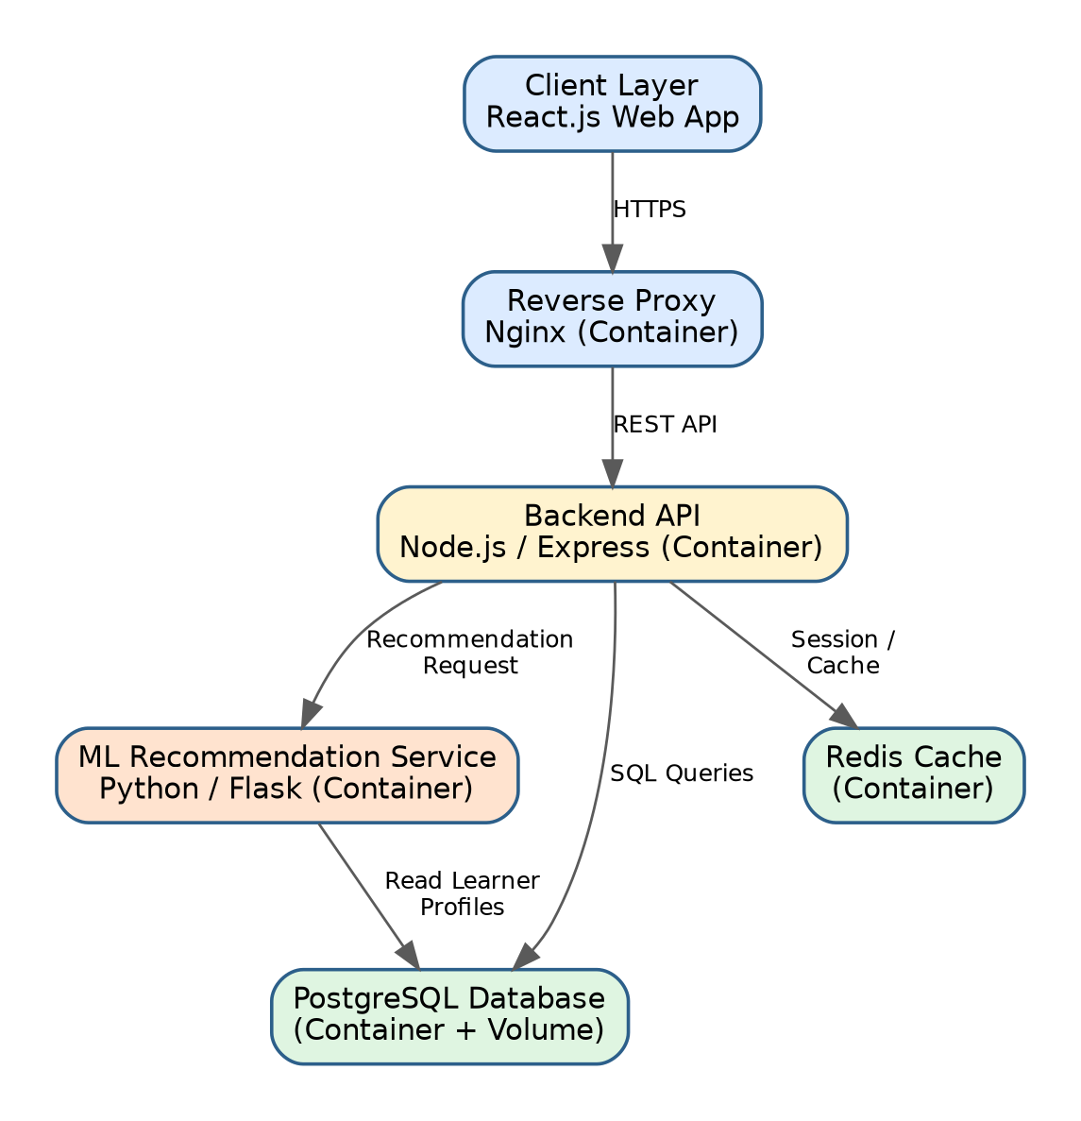

Figure 7.1 — SkillSphere containerized architecture
 | Container Rationale
Frontend (React) | Built into static assets and served via Nginx inside its own lightweight container.
Backend API (Node.js/Express) | Isolated runtime with its own Node version and npm dependencies; exposes REST endpoints to the frontend.
ML Recommendation Service (Python/Flask) | Requires scikit-learn/pandas and a Python runtime entirely separate from Node.js; containerized independently so it can be scaled or retrained without affecting the API.
PostgreSQL Database | Containerized with a named volume so learner and recommendation data persists across container restarts.
Redis Cache | Containerized to store sessions and cache frequent recommendation queries for faster dashboard response.

7.3 Design Considerations
- Each service gets its own Dockerfile and its own image, following the single-responsibility principle at the container level.
- Services communicate over an internal Docker network (skillsphere-net) rather than exposing every port publicly.
- Persistent data (Postgres, Redis) is stored in named Docker volumes so it survives container recreation.
- Environment-specific configuration (API keys, DB credentials) is injected via environment variables rather than hard-coded into images.

CHAPTER 8

DOCKERFILE DEVELOPMENT

8.1 Backend Dockerfile (Node.js / Express)
# backend/Dockerfile
FROM node:20-alpine AS base
WORKDIR /usr/src/app

COPY package*.json ./
RUN npm ci --omit=dev

COPY . .

ENV NODE_ENV=production
EXPOSE 5000

CMD ["node", "src/server.js"]
Figure 8.1 — Dockerfile for the backend API service

8.2 ML Service Dockerfile (Python / Flask)
# ml-service/Dockerfile
FROM python:3.11-slim
WORKDIR /app

COPY requirements.txt .
RUN pip install --no-cache-dir -r requirements.txt

COPY . .

EXPOSE 6000
CMD ["python", "app/api.py"]
Figure 8.2 — Dockerfile for the ML recommendation service

8.3 Frontend Dockerfile (React, Multi-Stage Build)
# frontend/Dockerfile
FROM node:20-alpine AS build
WORKDIR /app
COPY package*.json ./
RUN npm ci
COPY . .
RUN npm run build

FROM nginx:alpine
COPY --from=build /app/build /usr/share/nginx/html
EXPOSE 80
CMD ["nginx", "-g", "daemon off;"]
Figure 8.3 — Multi-stage Dockerfile for the React frontend

8.4 Purpose of Each Instruction
Instruction | Purpose
FROM | Selects the base image (e.g. node:20-alpine, python:3.11-slim) that provides the language runtime.
WORKDIR | Sets the working directory inside the container for all subsequent instructions.
COPY package*.json ./ / COPY requirements.txt . | Copies only dependency manifests first so Docker can cache the dependency-install layer separately from source code.
RUN npm ci / pip install | Installs exact, locked dependencies inside the image.
COPY . . | Copies the remaining application source code into the image.
ENV | Sets environment variables such as NODE_ENV=production inside the container.
EXPOSE | Documents which port the service listens on.
CMD | Defines the default command executed when the container starts.
Multi-stage FROM ... AS build | Keeps the final frontend image small by discarding the Node.js build toolchain and shipping only the compiled static assets served by Nginx.

CHAPTER 9

DOCKER COMPOSE DESIGN

9.1 docker-compose.yml
version: "3.9"

services:
frontend:
build: ./frontend
ports:
- "3000:80"
depends_on:
- backend
networks:
- skillsphere-net

backend:
build: ./backend
ports:
- "5000:5000"
env_file: .env
environment:
- DB_HOST=db
- REDIS_HOST=redis
- ML_SERVICE_URL=http://ml-service:6000
depends_on:
- db
- redis
- ml-service
networks:
- skillsphere-net

ml-service:
build: ./ml-service
ports:
- "6000:6000"
depends_on:
- db
networks:
- skillsphere-net

db:
image: postgres:16-alpine
restart: always
environment:
- POSTGRES_DB=skillsphere
- POSTGRES_USER=admin
- POSTGRES_PASSWORD=${DB_PASSWORD}
volumes:
- pgdata:/var/lib/postgresql/data
- ./database/init.sql:/docker-entrypoint-initdb.d/init.sql
networks:
- skillsphere-net

redis:
image: redis:7-alpine
volumes:
- redisdata:/data
networks:
- skillsphere-net

volumes:
pgdata:
redisdata:

networks:
skillsphere-net:
driver: bridge
Figure 9.1 — docker-compose.yml for SkillSphere
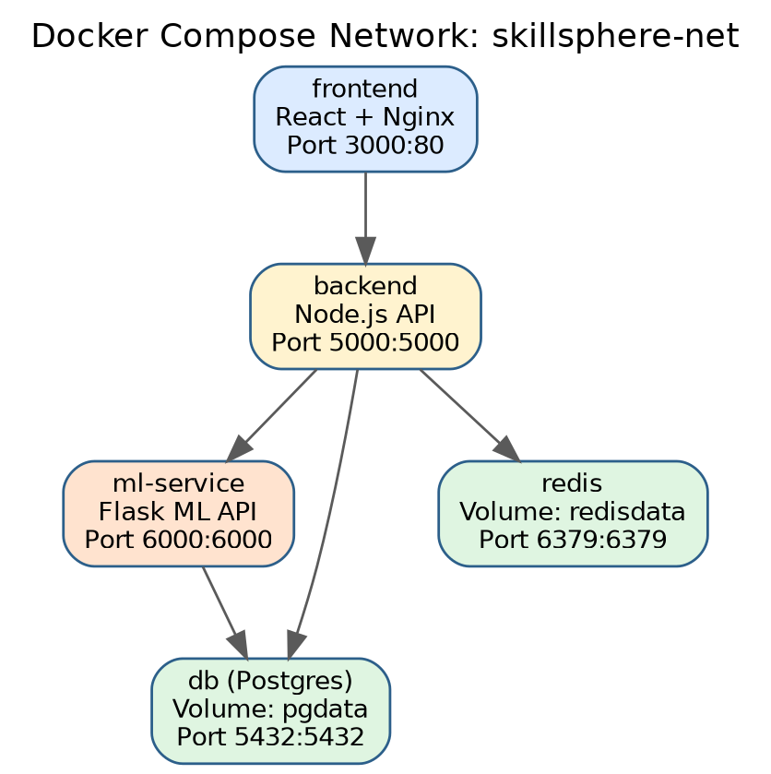
Figure 9.2 — Docker Compose service and network topology

9.2 Services, Networking, Volumes, and Dependencies
- Services: frontend, backend, ml-service, db, and redis are each defined as an independent service built from its own Dockerfile or a pinned official image.
- Networking: all services join the custom bridge network skillsphere-net, allowing containers to resolve each other by service name (e.g. the backend reaches the database at host db) without exposing internal ports to the host.
- Volumes: named volumes pgdata and redisdata persist database and cache data outside the container lifecycle, so data survives docker compose down and container recreation.
- Environment Variables: sensitive configuration (DB_PASSWORD) is supplied via an .env file referenced with env_file and ${...} interpolation, keeping secrets out of the committed docker-compose.yml.
- Dependencies: depends_on ensures the database, cache, and ML service start before the backend, and the backend starts before the frontend, reflecting the runtime dependency chain shown in Figure 9.2.

CHAPTER 10

CONTAINER DEPLOYMENT AND TESTING

10.1 Building and Running the Application
$ cp .env.example .env # fill in DB_PASSWORD and other secrets
$ docker compose build
$ docker compose up -d

[+] Running 6/6
✔ Network skillsphere_skillsphere-net Created
✔ Volume skillsphere_pgdata Created
✔ Volume skillsphere_redisdata Created
✔ Container skillsphere-db-1 Started
✔ Container skillsphere-redis-1 Started
✔ Container skillsphere-ml-service-1 Started
✔ Container skillsphere-backend-1 Started
✔ Container skillsphere-frontend-1 Started

$ docker compose ps
NAME STATUS PORTS
skillsphere-frontend-1 Up 10 seconds 0.0.0.0:3000->80/tcp
skillsphere-backend-1 Up 12 seconds 0.0.0.0:5000->5000/tcp
skillsphere-ml-service-1 Up 14 seconds 0.0.0.0:6000->6000/tcp
skillsphere-db-1 Up 15 seconds 0.0.0.0:5432->5432/tcp
skillsphere-redis-1 Up 15 seconds 0.0.0.0:6379->6379/tcp
Figure 10.1 — Building and starting the SkillSphere container stack

10.2 Testing Procedure
- Health check: curl http://localhost:5000/api/health confirms the backend API responds with { "status": "ok" }.
- Database connectivity: the backend logs a successful PostgreSQL connection on startup, verifying the db service and init.sql schema loaded correctly.
- Recommendation flow: a POST request to /api/recommendations with a sample learner profile returns a JSON list of recommended courses generated by the ml-service container, confirming inter-container communication over skillsphere-net.
- Frontend smoke test: opening http://localhost:3000 in a browser loads the React dashboard, which fetches and displays live data from the backend.
- Persistence test: docker compose down followed by docker compose up -d confirms learner datais still present, validating that the pgdata volume correctly persists state.
{"status":"ok","service":"skillsphere-backend"}

$ docker compose logs backend --tail 5
backend-1 | Connected to PostgreSQL at db:5432
backend-1 | Connected to Redis at redis:6379
backend-1 | SkillSphere API listening on port 5000
Figure 10.2 — Evidence of successful container health check and service connectivity

10.3 Evidence of Successful Execution
All five containers reached and remained in the Up state, the frontend successfully rendered learner dashboards populated by live backend data, and the recommendation endpoint returned correctly structured JSON generated by the ML service. These results confirm that the containerized SkillSphere stack runs successfully end-to-end using only the docker-compose.yml configuration, without any manual environment setup beyond populating the .env file.

CHAPTER 11

BENEFITS OF GIT AND DOCKER

11.1 Collaboration
Git's branch-per-feature workflow (Chapter 4) allowed multiple contributors to work on the React dashboard, the recommendation engine, and the Docker infrastructure simultaneously without blocking one another, while pull requests provided a structured checkpoint for code review before changes reached develop or main.

11.2 Version Management
Every change to SkillSphere — from a new ML model to a Dockerfile tweak — is captured as a discrete, reversible commit. This makes it possible to trace exactly when the recommendation logic changed, roll back a problematic release, and confidently experiment on feature branches without risking the stable main branch.

11.3 Portability
Because every SkillSphere service is described declaratively in a Dockerfile and orchestrated via docker-compose.yml, the entire platform can be brought up identically on a contributor's laptop, a CI runner, or a cloud VM with a single docker compose up command — eliminating the Node.js/Python dependency-conflict issues that would otherwise arise from installing everything directly on a host machine.

11.4 Deployment
Docker images built from the same Dockerfiles used in development can be pushed to a container registry and deployed to staging or production, ensuring the exact code and dependency versions that were tested are what actually runs in production.

11.5 Scalability
Because the ML recommendation service is containerized independently of the backend API, it can be scaled horizontally (docker compose up --scale ml-service=3) during peak usage — for example at the start of a semester when many students update their profiles — without needing to scale the entire application.

11.6 Maintainability
The combination of a clean branching history with conventional commit messages (Chapter 6) and isolated, single-responsibility containers (Chapter 7) makes it straightforward for new contributors to understand both how the codebase evolved and how the running system is structured, reducing onboarding time and long-term technical debt.

CHAPTER 12

CHALLENGES AND IMPROVEMENTS

12.1 Challenges Encountered
Challenge | Description
Merge conflicts | Overlapping edits to shared files such as backend/src/routes/api.js required manual conflict resolution when two feature branches modified nearby code (Section 5.3).
Cross-service environment parity | Ensuring the Node.js and Python services used consistent, compatible versions of shared configuration (e.g. API contracts) across containers required careful coordination of environment variables.
Container startup ordering | depends_on only waits for a container to start, not for the service inside it (e.g. PostgreSQL) to be ready, occasionally causing the backend to attempt a database connection before Postgres finished initialising.
Image size and build time | Early Docker images bundled unnecessary build tooling, resulting in slow builds and large images before multi-stage builds were introduced for the frontend.
Secret management | Avoiding accidental commits of the .env file (with real database credentials) required careful .gitignore configuration and reviewer vigilance.

12.2 Possible Improvements
- Health-check-aware startup: Add Docker Compose healthcheck directives to the db and redis services so dependent containers wait for true readiness, not just process start.
- Automated CI/CD: Extend the GitHub Actions workflow to automatically build and push Docker images, and to run integration tests against the full docker compose stack on every pull request.
- Branch protection rules: Enforce mandatory PR review and passing CI checks before merging into develop or main to catch conflicts and regressions earlier.
- Secrets management service: Replace plain .env files with a managed secrets store (e.g. Docker secrets or a cloud secret manager) for production deployments.
- Smaller, cached images: Continue refining multi-stage builds and dependency-layer caching across all services to reduce build time and image size.
- Semantic versioning and automated changelogs: Use conventional commit history to auto-generate release notes and enforce semantic version bumps on each release branch.

REFERENCES
[1] Scott Chacon and Ben Straub, Pro Git, 2nd Edition, Apress, 2014.
[2] Docker Inc., Docker Documentation — https://docs.docker.com/
[3] Docker Inc., Docker Compose Specification — https://docs.docker.com/compose/
[4] Vincent Driessen, “A successful Git branching model,” nvie.com, 2010.
[5] GitHub Inc., GitHub Docs — https://docs.github.com/
[6] Ian Sommerville, Software Engineering, 10th Edition, Pearson, 2015.
[7] Pressman, R. S., and Maxim, B. R., Software Engineering: A Practitioner's Approach, McGraw-Hill.
[8] PostgreSQL Global Development Group, PostgreSQL Documentation — https://www.postgresql.org/docs/
[9] Redis Ltd., Redis Documentation — https://redis.io/docs/
[10] Node.js Foundation, Node.js Documentation — https://nodejs.org/docs/
[11] React, React Documentation — https://react.dev/
[12] Conventional Commits Specification — https://www.conventionalcommits.org/

